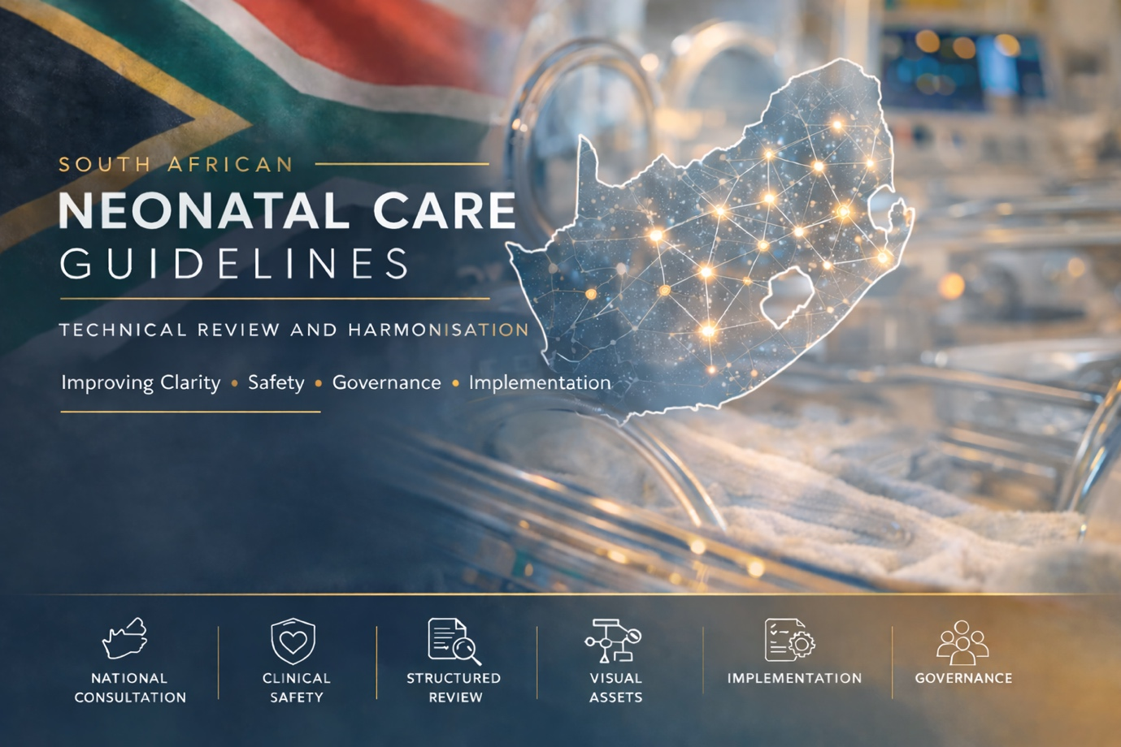

The following link contains;
1. Initial Guideline Document with all comments

This link contains a reprorosiotty with all comemts smare and per chapter and why changes made and for dicuso

FOREWORD 9
ACKNOWLEDGEMENTS 11
Lead Authors and Contributors 11
Chapter Authors and Contributors 11
ABBREVIATIONS AND ACRONYMS 16
DEFINITIONS AND TERMINOLOGY 22
Units & Conversions Relevant to Neonatal Dosing 24
INTRODUCTION 25
Medico-Legal Implications for These Guidelines 25
Implications For Hospital Management 25
Training 26
Litigation 26
CHAPTER 1: Perinatal Care 27
Prenatal Assessment 27
Antenatal Methods for Assessing Gestational Age 27
History Taking: Maternal History 28
Preparing for the Neonate Before Delivery 31
Introduction 31
Infection Control 31
Understanding Fetal Circulation 31
Neonatal Resuscitation and Helping Babies Breathe (HBB) 32
Staff Attending the Delivery 36
Equipment And Environment 36
At Delivery: Immediate Care of the Newborn 40
Do’s 40
Dont’s 40
Clinical Considerations During Neonatal Resuscitation 41
Referral Pathways 42
Roles and Requirements 42
Indications for Referral at Birth 42
Clinical Governance: Referrals and Record Keeping 43
Documentation at the Time of Referral 43
Referral Outcome and Responsibility 44
Care While Awaiting Transfer 45
Maternal Medical Conditions 46
Hypertension 46
Antepartum Haemorrhage 47
HIV 48
Asthma 49
Cardiac Disease 50
Diabetes 52
Epilepsy 53
Thyroid Disorders 55
Hepatitis B 57
CHAPTER 2: ASSESSMENT OF THE NEWBORN AT BIRTH 58
Introduction 58
Definitions and Classifications 58
Gestational Age (GA) Categories 58
Birth Weight Categories 58
Weight-for-Gestational-Age Classification 59
Small for Gestational Age 59
Intrauterine Growth Restriction (IUGR) 60
Neonatal History 62
Assessment of Wellbeing at Birth 62
Apgar Score 62
Resuscitation History 62
Anthropometry 63
Growth Charts 65
Postnatal Assessment of Gestation Age 72
New Ballard Score 72
Foot Length 73
Physical Examination of the Newborn 75
Environment and Infection Control 76
General Principles 76
Equipment 76
Newborn Examination Algorithm and Referral Triggers 78
CHAPTER 3: CARE OF THE WELL NEAR-TERM AND TERM NEWBORN WITH NORMAL BIRTH WEIGHT 87
Introduction 87
Management Principles: Babies ≥ 2500 Grams at Birth 87
Hand Hygiene 87
Immediate Care at Birth 88
Assessment and Stabilisation 88
Delayed Cord Clamping 88
Temperature Control 88
Skin-to-Skin and Early Breastfeeding 88
Newborn Examination 89
Newborn Prophylaxis 89
Postnatal Care 90
Feeding 90
Glucose Management 91
Bathing Practices (Advice for parents on discharge) 92
Urination 94
Stools 94
Failure to First Meconium First 48 Hours of Life 95
Umbilical Cord Care 96
Jaundice 96
Birth Immunisations 98
Discharge Planning 98
Minimum Criteria for Discharge of a Well Late Preterm and Term Newborn 99
CHAPTER 4: CARE OF THE SMALL AND SICK NEWBORN WITH LOW BIRTH WEIGHT 100
Introduction 100
Management Principles: Babies < 2500 Grams at Birth 100
Delivery Plan 101
Admission, Observation, and Transfer Criteria 101
Immediate Care at Birth 102
Birth Interventions to Reduce Morbidity and Mortality in LBW Babies 102
Prevention of Hospital-Acquired Infection 102
Preventing Hypoxia: Initial Assessment and Stabilisation 102
Preventing Hypothermia and Hyperthermia at Birth 102
Preventing Hypoglycaemia 105
Delayed Cord Clamping 105
Newborn Prophylaxis 105
Chloramphenicol (Chloromycetin) 106
Vitamin K 106
When to Refer? 106
Preventing Hypothermia During Interfacility Transfers 107
Postnatal Care 107
Preventing Hypothermia Between Admission Areas 107
Vital Signs: Monitoring and Observation 107
Temperature Monitoring 108
Management of Hypothermia 109
Incubator Use and Set-up 110
Servo-Controlled Incubators 110
Placement and T° Probe Positioning 111
Temperature Control and Monitoring 111
Sepsis Risk Factors 113
Newborn Examination 114
Jaundice 114
Urine 115
Stools 115
Birth Immunisations 115
Umbilical Cord 116
Skin Care 116
Discharge Planning 117
Minimum Criteria Before Discharge (Low Birth Weight Newborns) 117
Discharge Checklist 118
Follow-up After Discharge 120
CHAPTER 5: PREVENTION, OPTIMISATION AND CARE OF THE PREMATURE BABY 121
Introduction 121
Framework for Reducing Preterm Births and Deaths 123
Addressing Factors Contributing to Preterm Birth 124
Optimising Neonatal Outcomes in Preterm Labour 125
Care in Hospital for Premature Babies 127
CHAPTER 6: KANGAROO CARE 134
Definitions 134
Timing and Types of Kangaroo Mother Care 134
Algorithm: Skin-to-Skin Care 137
Steps to Successful Kangaroo Mother Care 139
Infrastructure and Resources: Kangaroo Mother Care Unit 140
Kangaroo Position 143
Kangaroo Nutrition 144
Kangaroo Support and Supervision 146
Discharge Planning in Kangaroo Mother Care 149
CHAPTER 7: NEONATAL NUTRITION: FEEDING AND FLUID MANAGEMENT 151
Introduction and Policy Context 151
Feeding Choice 151
Feeding Route 153
Feeding Initiation and Advancement 157
Stepwise Approach to Feeding 157
Feeding Method: Bolus versus Continuous Feeds 163
CHAPTER: Respiratory System 164
Apnoeas 164
CHAPTER: Cardiac Diseases 172
Introduction 172
Cardiovascular Assessment 172
Cyanosis 173
Cardiovascular Assessment 177
Cardiovascular Assessment 179
Pulse Oximetry Screening 179

FOREWORD
The National Department of Health has recommitted to the acceleration of interventions towards achieving Sustainable Development Goals 3.1 and 3.2. While the county achieved the SDG target 3.2 of 12/1000 live births in 2020 already, we are faced with emerging unacceptable rates in stillbirth rates of just above 30/1000 live births against the target of 12/1000 live births. SDG 3.1 target of maternal mortality on the other hand, continued to fluctuate, reaching the lowest performance of 88/100 000 live births in 2020 before plunging to 121/100 000 in 2022 then slowly recovering to just below 100/100 000 live births in 2023. While the fluctuations are not helpful working towards attainment of maternal mortality ratio to < 70 deaths per 100 000 live births in 2030, they provided an opportunity to identify the weakest link within the health system. It is with no doubt that we have a better handle on the clinical interventions in reducing both maternal and peri-natal mortalities, all we need is to scale up all pockets of good practices and incorporate emerging new technology evidence.
As a country we cannot underscore the insight shared through the recommendations arising from the triennial Saving Mothers and Saving Babies Reports that have been produced by two Ministerially appointed committees: the National Committee on Confidential Enquiries into Maternal Deaths (NCCEMD) and the National Perinatal Morbidity and Mortality Committee (NaPeMMCo). The recommendations for these committees provide a platform for regular update and strengthening of policy and guidelines on the clinical management of the common causes of maternal and new-born deaths in South Africa.
I am proud to announce that the guidelines for maternal and newborn care were expanded to have three distinct (but interlinked) documents which are: an updated version of maternal and care, a completely new guideline on newborn care including management of small and sick neonates, and maternal and peri natal specific health system related guidelines. The change in approach aims to build more resilient health system to minimise the impact of pandemics, crisis situations and other health systems challenges such as skilled health care workers, availability of commodities and supplies.
There is in these guidelines, evidence-based substantive changes that describe the integrated antenatal and intrapartum care rendered since the previous version of the maternal guideline (fourth edition; 2016) in alignment with some of the World Health Organisation recommendations of positive childbirth experience. Introduction of eight (8) ante natal visits which was central to the implementation of Basic Antenatal Care (BANC) Plus, revised Labour Care Guide, respectful maternity care, prevention and identification of intimate partner violence and mental health were amongst the critical changes effected.

The implementation of these guidelines will assist the country in responding to some of litigations associated with maternal and peri-natal services. Further these guidelines are tailored to support clarity on service delivery platform constraints and commitments by government and other relevant stakeholders. It also provides an opportunity to introduce the self-care concept where women of reproductive age viewed as partners in the maternal and perinatal health service.
I here acknowledge the huge contribution that managers, scholars, clinicians and frontline workers and researchers put in the production of these guidelines.
Dr SSS Buthelezi
DIRECTOR GENERAL: Health, National Department of Health
Date:

ACKNOWLEDGEMENTS

Lead Authors and Contributors

Lead Authors
Professor Gugu Kali (SU) and Professor Shakti Pillay (UCT)
Editor: Dr David Ntirushwa ( WHO) and Professor Shakti Pillay
Technical Consultant: Dr Joan Diepenaar

National Department of Health Leads
Dr Manala Makua ( Chief Director: WMRH)
Ms E. Mokaba (Director: MNH )
Ms J Mahuntsi (Deputy Director: MNH)

The National Department of Health, Women’s Maternal and Reproductive Health (WMRH) Chief Directorate and Maternal & Neonatal Health Directorate with the support of the World Health Organization (WHO) and United Nations Children’s Fund (UNICEF) country offices representatives, gratefully acknowledge the contributions that many individuals and organisations have made to the development of these guidelines.

Special thanks to the lead authors, especially the clinical specialists and academia, for reviewing scientific evidence on clinical interventions and the WHO support with the latest evidence-based recommendations on which these guidelines are based.

We thank all the writing retreat attendees who represented various organisations, provincial representations during the guideline development process. We appreciate the feedback provided by a large number of frontline clinicians and stakeholders during the virtual meetings and physical writing retreats and workshops that took place as part of the guideline development process. We also appreciate Clinton Health Access Institute, WHO, and UNICEF, who provided logistical support for writing retreats.

Chapter Authors and Contributors

CHAPTER AUTHORS (Alphabetical by Surname)
Dr Inge Beat  Dr Anisa Bhettay  Dr Nicolette Brown  Ms Ruth Davidge  Dr Joan Dippenaar (UNICEF)  Dr Sthembile Dlamini  Prof Angela Dramowski  Dr Christel du Buisson (SU)  Dr Ida du Plessis  Prof Ute Feucht (UP)  Prof Karen Fieggen (UCT)  Dr Yasmeen Ganie  Dr Nelesh Govender  Dr Hassena Hassan  Prof Alan Horn (UCT)  Dr Mercy Kamupira  Ms Zandile Kubeka  Ms Trudy Leong (SAMRC)  Ms Theresa Makatane (NaPeMMCo)  Dr Nomlindo Makubalo (NaPeMMCo) | Dr Khomotso Masemola  Ms Lolly Mashao  Prof Dini Mawela (NaPeMMCo)  Prof Mignon McCulloch (UCT)  Dr Shaneen Mehtar  Dr Tsele Mosia (NaPeMMCo)  Dr Lerusha Naidoo  Prof Firdose Nakwa  Prof Olga Perovic  Dr Natasha Rhoda  Dr Asma Saloo  Dr Lino Sono (NaPeMMCo)  Dr Radhika Singh  Dr Reenu Thomas  Mr Gilbert Tshitaudzi (UNICEF)  Dr Arina van der Byl  Dr Alison van Kwawegen  Dr Yolanda van Zyl  Prof Sthembiso Velaphi (NaPeMMCo)

ADDITIONAL CONTRIBUTORS
National Department of Health (NDoH) Programme Leads (Alphabetical by Surname)
Ms D Chweneyagae  Ms K Khosa  Ms Z Kubeka  Ms V Lebese  Ms R Maithufi  Ms CM Ngoepe | Ms S Ngake  Ms M Ntloana  Ms J Sebidi  Ms N Somnath  Dr AK Vilakazi-Nhlapo

PROVINCIAL REPRESENTATION (ALPHABETICAL BY SURNAME)
Eastern Cape
Mrs N Gwiji | Ms M Mayer
Dr K Harper | Ms F Ngamlana
Prof MS Mabenge | Ms N Ntissa
Ms N Magingxa | Ms F Spayila
Free State
Ms NJ Isaacs | Ms R Motete (SOMSA)
Ms L Juleka | Ms MH Motampane
Ms M Kumpi | Dr T Nondabula
Ms MT Makatane | Ms TA Nkonyane
Dr T Mosia | Mrs T Sithole
Gauteng
Mrs Q Baloyi | Ms DV Masola
Ms J Boshielo | Ms N Majosi
Ms LR Komane | Ms O Mongale
Prof Z Dangor | Dr MR Musie
Ms DM Leso | Ms N Mtembu
Ms MI Machaba | Ms M Mokone
Ms MJ Machaba | Ms NT Molepo
Ms M Madumise | Ms B Motadi
Ms R Makau | Mr KJ Nyalungu
Ms PJM Makgamathe | Ms NSM Ngidi
Ms M Makgothloe | Ms ND Nyai
Ms ME K Makobe | Ms MD Rakgolela
Mrs NB Mapasha | Prof MLM Sengane
Ms TI Matheala | Ms BM Setshedi
Ms MJ Matlhoko-Rikhotso | Ms GN Simelane
Mr/Ms MM Meldah | Ms NC Xotongo
Ms R Mkhwanazi | Ms T Zwane
Mr SS Masilela

KwaZulu-Natal (KZN)
Dr R Bhoola | Ms TJ Mpembe
Ms N Dlamini | Ms P Muthuphei
Dr TL Khumalo | Ms P Phungula
Ms K Makhathini
Mpumalanga (MP)
Ms P Dlamini | Ms T Mazibuko
Ms SN Kabini | Ms HV Mokoena
Mr J Mahlangu | Ms N Sibeko
Mr N Manana | Dr L Sino
Ms A Mashele
North West
Ms F Boer | Ms CN Modise
Ms R Jooste | Ms BR Monei
Dr S Komane | Ms KB Mooba
Ms P Maluleke | Dr MG Mothupi
Ms MJ Mamabolo | Mrs EMN Nonovi
Northern Cape
Ms M De Wet | Ms CW Sesing
Ms MJ Diphoko | Dr G Umpierrez Tores
Dr ND Lengo | Ms FL Witbooi
Dr MH Muller
Western Cape
Ms N Henney | Prof G Petro
Academia
Prof A Dramowski (SU) | Dr M Musie (UP)
Prof W Lubbe (NWU) | Prof N Ngunyulu (UJ)
Prof C Maree (UP/NNASA) | Ms N Thembekile (UJ)

Partners
Dr B Buthelezi (USAID) | Ms E Leonard (CHAI)
Dr R Dansowaa Doe (WHO) | Dr B Mugisa (USAID)
Dr S Dlamini (WHO) | Dr N Manzini (UNFPA)
Dr J Dippenaar (UNICEF) | Prof Y Pillay (CHAI)
Ms L Khan (CHAI) | Ms P Robinson (Right to Care)
Dr M Kamupira (UNICEF)

Organisations / Institutions
Dr J Ambler (KZN-Umduduzi) | Prof H Rees (WRHI)
GELA Guideline Group & Team (SAMRC) | Ms L Shuping (NICD)
Ms H Ismail (NICD) | Mr P Thekisho (RMHC, SA)
Ms S Jordan (SABR) | Ms M Wibbelink (Sensitive Midwifery)
Ms R Motete (SOMSA) | Prof O Perovic (NICD)
Dr F Patel (WITS RHI)
Abbreviations: CHAI: Clinton Health Access Initiative; GELA: Global Evidence, Local Adaptation; KZN: KwaZulu-Natal; NICD: National Institute for Communicable Diseases; NNASA: Neonatal Nurses Association of South Africa; NWU: North-West University; SABR: South African Birth Registry; SAMRC: South African Medical Research Council; SOMSA: Society of Midwives of South Africa; RMHC: Ronald McDonald House Charities; SU: Stellenbosch University; UCT: University of Cape Town; UJ: University of Johannesburg; UP: University of Pretoria; UNFPA: United Nations Population Fund; UNICEF: United Nations Children’s Fund; USAID: United States Agency for International Development; WHO: World Health Organisation. WRHI: Wits Reproductive Health and HIV Institute.

ABBREVIATIONS AND ACRONYMS
Abbreviations
ABG | Arterial Blood Gas
ACS | Antenatal Corticosteroids
aEEG | Amplitude Integrated Electroencephalography
AKI | Acute Kidney Injury
ANC | Antenatal Care
ART | Antiretroviral Therapy
ASD | Atrial Septal Defect
AVSD | Atrioventricular Septal Defect
AXR | Abdominal X-ray (radiography)
BCG | Bacille Calmette-Guérin
BP | Blood Pressure
Bpm | Beats Per Minute
BS | Burst Suppression
BW | Birth Weight
Ca⁺² | Calcium
CAH | Congenital Adrenal Hyperplasia
CGA | Corrected Gestational Age
CHD | Congenital Heart Disease
CHW | Community Health Worker
CrI | Credible Interval
CLV | Continuous Low Voltage
CMP | Calcium, Magnesium and Phosphate
CMV | Cytomegalovirus
CNS | Central Nervous System
CO₂ | Carbon Dioxide
CPAP | Continuous Positive Airway Pressure
CPR | Cardiopulmonary Resuscitation
CRI | Congenital Rubella Infection
CRP | C-reactive Protein
CRS | Congenital Rubella Syndrome
CSF | Cerebrospinal Fluid
CTG | Cardiotocography
CUS | Cranial Ultrasound Scan
CXR | Chest X-Ray (radiography)
DEBM | Donar Expressed Breastmilk
DSD | Difference of Sex Development
EBF | Exclusive Breast Feeding
ECG | Electrocardiography
ECMO | Extracorporeal Membrane Oxygenation
EEG | Electroencephalography
ELBW | Extremely Low Birth Weight
EPI | Expanded Programme on Immunisation
ESPGHAN | European Society of Paediatric Gastroenterology, Hepatology and Nutrition Committee
ETT | Endotracheal Tube
EUS | Early Ultrasound Scan
F | French
FBC | Full Blood Count
FFP | Fresh Frozen Plasma
FiO₂ | Fractional Inspired Oxygen
FT | Flat Tracing
GA | Gestational Age
GBS | Group B Streptococcus
GFR | Glomerular Filtration Rate
GT | Gastric Tube
Hb | Haemoglobin
HBA₁C | Glycated Haemoglobin
HFNC | High Flow Nasal Cannula
HIE | Hypoxic Ischaemic Encephalopathy
HIV | Human Immunodeficiency Virus
HLHS | Hypoplastic Left Heart Syndrome
HMF | Human Milk Fortifier
HSV | Herpes Simplex Virus
IDM | Infant of Diabetic Mother
IEM | Inborn Errors of Metabolism
IM | Intramuscular
INA | Infant Neuromotor Assessment
IPPV | Intermittent Positive Pressure Ventilation
IU | International Units
IUGR | Intrauterine Growth Restriction
IV | Intravenous
IVH | Intraventricular Haemorrhage
K⁺ | Potassium
KMC | Kangaroo Mother Care
Kpa | Kilopascal
ℓ | Litre
LBW | Low Birth Weight
LFT | Liver Function Test
LGA | Large for Gestational Age
LOC | Level of Consciousness
LMIC | Low- and Middle-Income Countries
LP | Lumbar Puncture
MAS | Meconium Aspiration Syndrome
MBP | Mean Blood Pressure
MCR | Maternity Case Record
MDT | Multidisciplinary Team
Mg⁺² | Magnesium
MmHg | Millimetres of mercury
MOM | Mothers own milk
MOU | Midwife Obstetric Unit
MRI | Magnetic Resonance Imaging
MSL | Meconium-Stained Liquor
Na⁺² | Sodium
NEC | Necrotising Enterocolitis
NGT | Nasogastric Tube
NICU | Neonatal Intensive Care Unit
NPO | Nil per os
NPO₂ | Nasal Prong Oxygen
O-M-C-R | Observe-Measure-Check-Counsel-Refer
PA | Pulmonary Atresia
PCO₂ | Partial Pressure of Carbon Dioxide
PCR | Polymerase Chain Reaction
PDA | Patent Ductus Arteriosus
PEEP | Positive End Expiratory Pressure
PHC | Primary Health Care
PICC | Peripherally Inserted Central Catheter
PMA | Post Menstrual Age
PO₂ | Partial Pressure of Oxygen
POS | Pulse Oximetry Screening
PPHN | Persistent Pulmonary Hypertension of the Newborn
PROM | Prolonged Rupture of Membranes
PS | Pulmonary Stenosis
RDS | Respiratory Distress Syndrome
RPR | Rapid Plasma Reagin
RTHB | Road To Health Booklet
RR | Respiratory Rate
SA | South Africa
SGA | Small for Gestational Age
SUPC | Sudden Unexplained Postnatal Collapse
SVT | Supraventricular Tachycardia
T° | Temperature
T₄ | Thyroxine
TA | Tricuspid Atresia
TAPVC | Total Anomalous Pulmonary Venous Connection
TBW | Total Body water
TCB | Transcutaneous Bilirubinometer
TFI | Total Fluid Intake
TGA | Transposition of the Great Arteries
ToF | Tetralogy of Fallot
TOP | Termination of Pregnancy
TPHA | Treponema Pallidum Haemagglutination
TSB | Total Serum Bilirubin
TSH | Thyroid Stimulating Hormone
TTN | Transient Tachypnoea of the Newborn
UAC | Umbilical Arterial Catheter
UVC | Umbilical Venous Catheter
VL | Viral Load
VLBW | Very Low Birth Weight
VSD | Ventricular Septal Defect
VT | Ventricular Tachycardia
VTP | Vertical Transmission Prevention
WBOT | Ward-Based Outreach Teams
WHO | World Health Organisation

DEFINITIONS AND TERMINOLOGY
Terminology | Description
Chronological Age | Time elapsed since birth expressed in days, weeks, months, or years.
Corrected Gestational Age (cGA) | Chronological age adjusted for prematurity by subtracting the number of weeks' the baby was born before 40 weeks’ gestation. Used for infants born preterm from birth up to 3 years of age and expressed in weeks' or months.  Example: An infant aged 12-months, who was born at 28 weeks' gestational age has a cGA of 9 months.  During the hospital admission, “postmenstrual age” is the preferred term. After the perinatal period, “corrected gestational age” is preferred.
Extremely Low Birth Weight | Birth weight less than 1 000 grams.
Extremely Preterm | Babies born < 28 weeks’ gestational age.
Gestational Age | Time elapsed between the first day of the mother’s last menstrual period and the date of delivery, expressed in completed weeks'.
Large for Gestational Age (LGA) | Birth weight above the 90th percentile for gestational age.
Late Preterm | Babies born between 34 weeks and 36 weeks + 6 days.
Low Birth Weight | Birth weight less than 2 500 grams.
Macrosomia | Birth weight more than 4 000 grams.
Moderately Preterm | Babies born between 32 weeks and 33 weeks + 6 days.
Neonate | A baby ≤ 28 completed days of life.
Neonatal Period | The first 28 days of life.
Post-term | Babies born at ≥ 42 weeks’ gestation.
Postmenstrual Age (PMA) | Gestational age at birth plus chronological age, expressed in weeks.  Example: A baby born at 28 weeks’ gestation who is now 8 weeks old has a PMA of 36 weeks.
Preterm | Babies born before 37 completed weeks of gestation.
Small for Gestational Age (SGA) | Birth weight below the 10th percentile for gestational age.
Term | Babies born between 37 weeks and 41 weeks + 6 days’ gestation.
Very Low Birth Weight (VLBW) | Birth weight < 1 500 grams.
Very Preterm | Babies born between 28 weeks and 31 weeks + 6 days’ gestation.

Units & Conversions Relevant to Neonatal Dosing
Accurate weight measurement and unit conversion are essential for safe neonatal prescribing and fluid management.

Unit |  | Conversion
1 kilogram (kg) | = | 1 000 grams (g)
1 gram (g) | = | 1 000 milligrams (mg)
1 milligram (mg) | = | 1 000 micrograms (mcg)
1 microgram (mcg) | = | 1 000 nanograms (ng)

INTRODUCTION
These guidelines were designed by interdisciplinary healthcare teams to provide safe newborn care based on best evidence and resources believed to be accurate and current at the time of release. These guidelines are intended to provide general advice and guidance and must not be solely relied upon as a substitute for assessing the individual needs of each baby. They must be used in conjunction with a thorough history and clinical examination and considering a particular clinical setting.
Although great care has been taken to avoid any errors or omissions in preparing these guidelines, there exists the potential for errors in both fact and opinion. Clinicians should consult other sources of information, particularly if there is any doubt, including the product. information sheets for drug dosages. The authors cannot be held responsible for any errors and take no responsibility for matters arising from changed circumstances or information that may have become available after the issued or review date.

Medico-Legal Implications for These Guidelines
These guidelines have been designed by the department of health to guide the care that is provided for pregnant women and neonates in South Africa. They represent the desired standard of care. Clinicians must be aware of the guideline contents and understand how to implement them.

These guidelines were designed by interdisciplinary healthcare teams to provide safe maternal care based on best evidence and our national context and are believed to be accurate and current at the time of release. These guidelines are intended to provide general advice and guidance and must not be solely relied upon as a substitute for assessing the individual needs of each mother. They must be used in conjunction with a thorough history and clinical examination and considering a particular clinical setting and resource availability.
Individual hospital and community health centres are encouraged to draw up their own protocols based on this content, adjusted to their own circumstances. Additionally, where resource constraints (staffing, infrastructure, equipment or other) prevent the full implementation of these guidelines, formal notification of the constraints and their impact on the ability of clinicians to follow these guidelines should be documented and sent to management.
Although great care has been taken to avoid any errors or omissions in preparing these guidelines, there exists the potential for both factual errors and differences of opinion. Clinicians should consult other sources of information, particularly if there is any doubt, including product information sheets for drug dosages. The authors cannot be held responsible for any errors and take no responsibility for matters arising from changed circumstances or information that may have become available after the issued or reviewed date.

Implications For Hospital Management

All Chief Executive Officers (CEOs) have a responsibility to ensure that every doctor and midwife working in maternity has easy access to a copy of these guidelines and that all staff understand they have a responsibility to follow the guidelines, or any local protocols derived from the guidelines.

Notification of any constraints (such as listed above) should be made to district or provincial management, as soon as possible, and reviewed at least annually. An example of a way of notifying challenges are provided in an addendum at the end of this guideline (Addendum 1).

In cases where resource constraints directly impact the care of individual patients, these impediments should be documented in the clinical notes (for example, an unusually busy theatre, or concurrent emergencies) and the CEO informed.

Training
All midwives and doctors working in maternity should aim to complete the ESMOE and other training programmes, with modules aligned to these guidelines. The aim is that ESMOE drills should occur at least monthly at every facility.

Litigation
Great strides have been made in improving health care in South Africa including maternity and neonatal care, however significant resource constraints still limit the full realisation of national health goals, and substantial disparity remains within and between provinces.

In the current South African medico legal context, the courts appear to have largely interpreted previous versions of these guidelines as an absolute set of standards without due consideration of the particular circumstances of the healthcare centre in question. The intention of section 27 of the Constitution requires progressive realisation of health care in South Africa and not an exact portrait of what is portrayed in the guidelines. It should be reiterated that the guidelines reflect best practice standards which may not yet be attainable in all circumstances.

The courts, when referencing these guidelines in the determination of whether negligent care was present or not, are urged to consider the matter from the perspective of section 27(2) of the Constitution, including, without limitation, the context in which the care took place, and whether the actions of the health care team under the particular circumstances were reasonable or not. Considering the matter from the perspective of section 27(2) of the Constitution requires a realisation that “the obligations imposed on the State by … s 27 in regard to access to … health care, [is] dependent upon the resources available for such purposes, and that the corresponding rights themselves are limited by reason of the lack of resources.”

CHAPTER 1: Perinatal Care

Prenatal Assessment



Antenatal Methods for Assessing Gestational Age

Table 1. Antenatal Methods for Assessing Gestational Age
Early Ultrasound Scan | Last Menstrual Period | Other
- Antenatal scan performed < 20 weeks’ gestation.  - Gold standard for assessing gestational age antenatally  - Not easily accessible in Low and Middle-Income Countries (LMIC).  - If no EUS is performed pregnancy is sub-optimally dated.  - Gold standard for assessing gestational age. | - Only reliable in women with regular 28-day cycles who closely track their ovulation.  - Unreliable in LMIC. | - Methods such as symphysis-pubis fundal height (SFH) are much less reliable and should not be relied on solely for assessment of gestational age (GA).

When an accurate antenatal GA is not available, please refer to Postnatal Assessment of Gestation Age (page 68).

History Taking: Maternal History
It is important to take a detailed maternal history, including review of the current pregnancy, labour, and delivery, as well as relevant past obstetric, surgical and medical history.

Current Pregnancy
Antenatal Maternal Profile
- Maternal age
- Gravidity and parity

Booking History and Antenatal Course
- Gestational age (GA) at booking and method of assessment [Last menstrual period - LMP; early ultrasound scan (EUS)]
- For each antenatal ultrasound scan document:
- GA at time of scan
- Structural anomalies: Present/absent
- Placental implantation, location and placenta praevia/accreta suspicion
- Amniotic fluid index
- Estimated fetal weight
- Fetal growth parameters and any concerns (Small for Gestational Age [SGA] / Large for Gestational Age [LGA])

Note: EUSs are not routinely performed for all pregnancies across all centres. Adhere to local facility policy and provincial obstetric protocols.

Maternal Health Status During Pregnancy
- Maternal infections during pregnancy e.g. urinary tract infection or tuberculosis.

Past Medical and Surgical History
Past Medical History including Treatment History
Chronic or pregnancy-related conditions
- Hypertension (HPT): Gestational or chronic HPT
- Diabetes: Gestational or pre-existing
- Thyroid disease
- Epilepsy
- Anaemia
- Cardiac disease
- Mental health conditions
- Autoimmune diseases

Drug History
Ask about dosage, frequency, route and when last used:
- Prescription medications
- Over-the-Counter medications
- Recreational substances including alcohol, tobacco, cannabis and cigarette smoking
- Traditional medications

Past Surgical History
- Previous surgeries: Type of surgery, indication, date, anaesthaesia (spinal or general), and any complications related to the procedure or anaesthaesia.

Family History and Socio-Economic Status
- Family history of congenital anomalies
- Early childhood deaths (cause and time of death if known)
- Significant neonatal jaundice in siblings
- Early male deaths (consider X-linked conditions such as haemophilia)
- Consanguinity
- Ethnicity (relevant for genetic risk patterns)
- Enquire about socio-economic circumstances, which includes financial stability, household support, and whether the pregnancy was planned or unplanned
- Assess safety and risk of gender-based violence (GBV) or intimate partner violence
- Enquire about home circumstances, including living conditions, caregiving support, and any social vulnerabilities

Previous Obstetric History
- Previous births and deaths
- For each viable previous pregnancy document, gestational age at birth, mode of delivery, gender, birth weight, complications and outcome
- Ask about assisted reproductive therapies
- For previous non-viable pregnancies (< 500 grams or < 26 weeks') establish whether this was a miscarriage (spontaneous or medically induced), termination of pregnancy, or ectopic pregnancy, and document the GA at the time.

Labour and Delivery
Mode of Delivery
- Normal vaginal delivery.
- Assisted delivery (forceps/vacuum).
- Caesarean section:
- Indication
- Spinal or general anaesthesia

Complications During Labour and Delivery
- Meconium-stained liquor.
- Rupture of membrane (ROM) duration: Prolonged > 18 hours.
- Cardiotocography (CTG) – normal or pathological?
- Partogram review – prolonged labour?

Maternal Health Status in Labour
- Maternal pyrexia
- Risk factors for chorioamnionitis/sepsis
- Group B Streptococcus (GBS) carrier status, where known

Note: GBS screening is not routinely performed for all pregnant women. A risk-based screening approach is applied in most settings; follow local obstetric policy.

Preparing for the Neonate Before Delivery

Introduction
- Adequate preparation for all deliveries is essential.
- Effective communication between the obstetric and neonatal teams is crucial.
- Communication with the mother and her birth companion should always be clear, and respectful.
- If feasible, communicate in the mother’s preferred language using interpreters or translation support.

Infection Control
- All health care workers, mothers, and birth companions must wash their hands with soap and water before entering the delivery area and use alcohol-based hand sanitiser before any further interaction with the mother, her baby or their surroundings.

Understanding Fetal Circulation
- Oxygen saturations are not expected to be normal immediately after delivery.
- Well newborns who do not require resuscitation typically have pre-ductal (right hand or right ear) oxygen saturations of 60-70% which gradually rise and may take 10 minutes or more to exceed 90% (Table 4).
- Preparation for immediate newborn care therefore requires an understanding of the physiological transition from intrauterine to extrauterine life (Figure 1).
- In most newborns (90%), these changes occur successfully without any intervention.

Key components of normal transition include:

- Clearance of fetal lung fluid
- Decrease in pulmonary vascular resistance
- Increase in pulmonary blood flow
- Conversion from fetal (parallel) to newborn (series) circulation
- Endocrine support of the transition

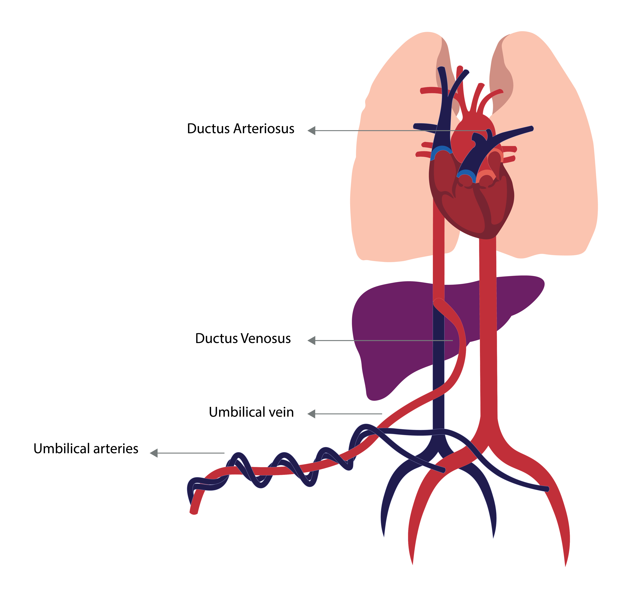
Figure 1. Fetal Circulation

Neonatal Resuscitation and Helping Babies Breathe (HBB)

10% of newborns require some respiratory assistance at birth and less than 1% need intensive resuscitation.
Maternal, antenatal, and intrapartum factors increase the likelihood that a newborn may require resuscitation (Table 2).

Mothers who deliver at Level 1 facilities (clinics/midwife obstetric units) are presumed to be low risk with no known risk factors. However, unanticipated complications may still arise in low-risk deliveries, and due to system, provider, or patient factors, high-risk deliveries may inadvertently occur at Level 1 facilities. Therefore, preparation for anticipated neonatal resuscitation is essential at any facility that offers maternal and newborn care.

In high-risk deliveries, if time permits, discuss the potential need for resuscitation with the parents before birth, with documentation.
Table 2. Risk Factors for Resuscitation at Birth
Antepartum Factors | Intrapartum Factors
Fetal  - Intrauterine growth restriction  - < 37 weeks’ gestation  - Multiple gestation  - Congenital abnormality  - Abnormal antenatal scan findings  - Oligo- or polyhydramnios  Maternal  - Maternal signs of sepsis (tachycardia, pyrexia)  - Maternal drugs (recreational and prescription)  - Gestational diabetes  - Pregnancy-induced hypertension  - Pre-eclampsia  - High body mass index (BMI)  - No antenatal steroids  - Short stature  - No prenatal care | - Fetal compromise - non-reassuring CTG  - Meconium-stained amniotic fluid  - Vaginal breech delivery  - Forceps or vacuum delivery  - Significant maternal bleeding  - Caesarean section < 39 weeks  - Emergency caesarean section  - General anaesthesia  - Delayed progress of labour

Initial Assessment at Birth

At birth, every newborn must be assessed immediately for breathing and crying.
Birth attendants must be skilled in immediate newborn care and basic resuscitation, with particular emphasis on the principles of the “Golden Minute” and Helping Babies Breathe (HBB).

Helping Babies Breathe (HBB)

Newborns who do not cry or breathe after adequate stimulation and correct positioning of the airway require positive pressure ventilation (PPV) within the Golden Minute.
Effective support of breathing during the first minute of life is essential to prevent neonatal hypoxia and improve survival outcomes.

Refer to the Helping Babies Breathe (HBB) algorithm for the initial steps within the Golden Minute, and the Neonatal Resuscitation Algorithm (Resuscitation Council of Southern Africa) for ongoing or advanced resuscitation.
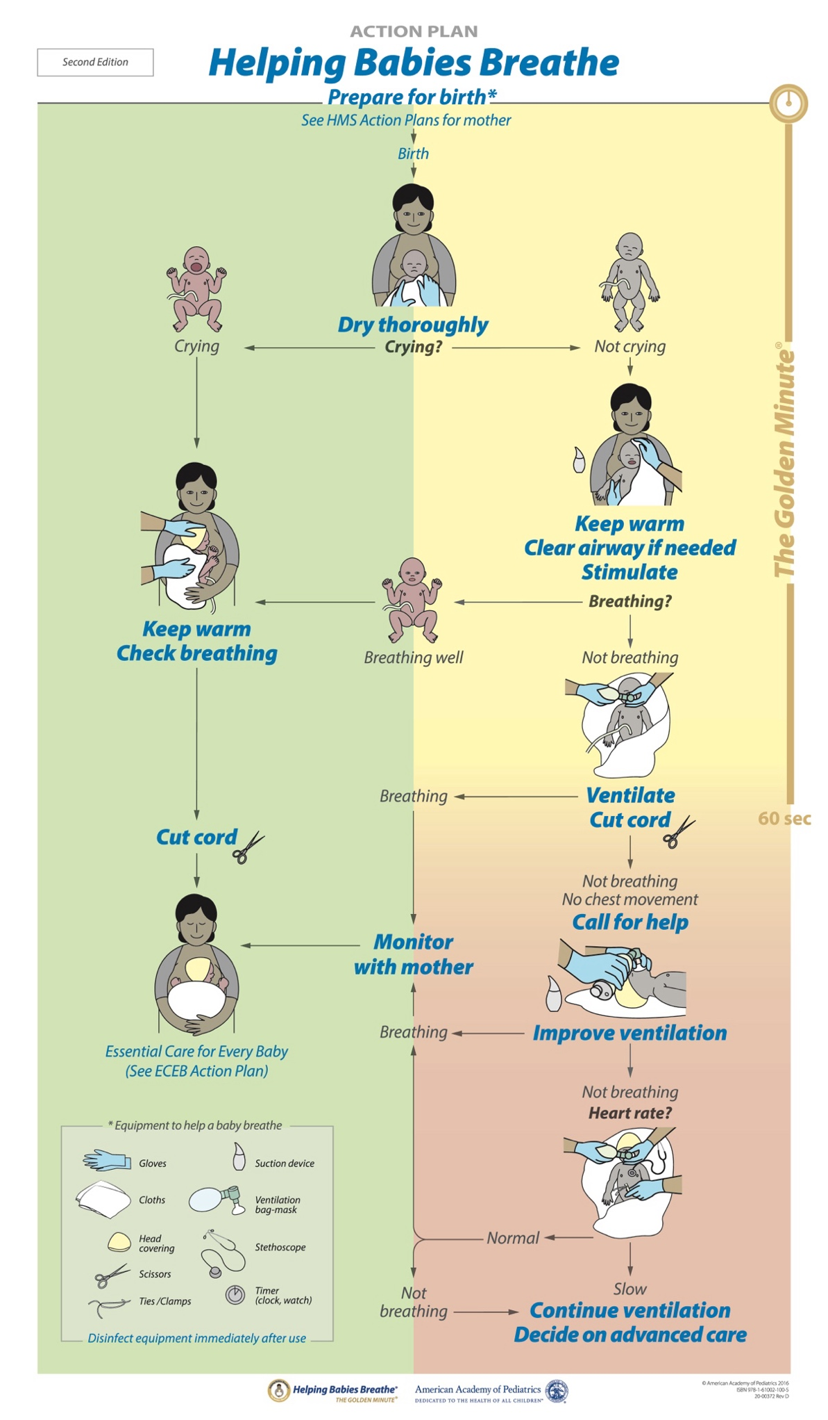
Figure 2. Helping Babies Breathe Action Plan
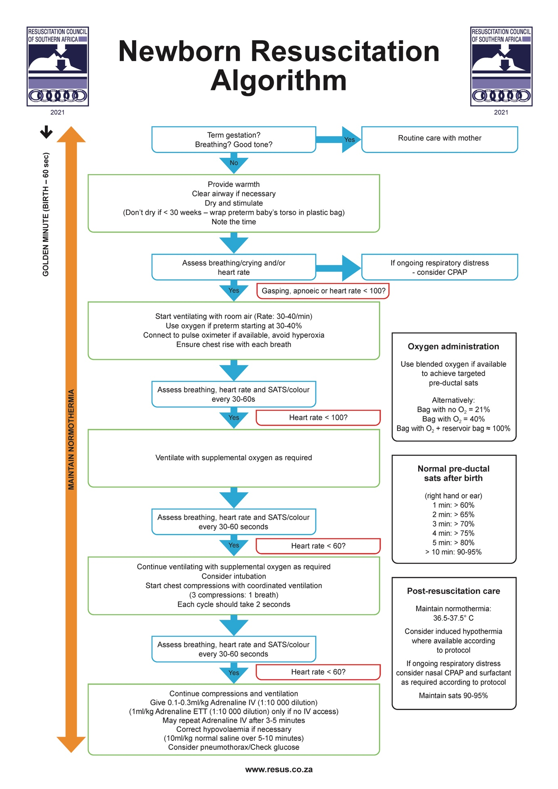

Figure 3. Newborn Resuscitation Algorithm (Resuscitation Council of Southern Africa)

Staff Attending the Delivery
At least one person competent in newborn life support and resuscitation whose sole responsibility is to care for the baby should be in attendance for all deliveries.
Identify a second person to help with resuscitation, should there be a need.
At level 2, 3 and 4 facilities a senior clinician available on site should be present for the golden minute for all complicated deliveries.
Each facility should have guidelines for indications and processes for rapidly mobilising additional assistance.
Be familiar with these emergency plans in your centre.

Equipment And Environment
Use a structured checklist to prepare the delivery environment and equipment (Table 3).
Ensure all resuscitation equipment is functional, properly assembled, and immediately available.
Keep the delivery area warm (23-25°C), well-lit, and free from draughts.
The resuscitation area should have a flat, firm surface and a pre-warmed radiant warmer or similar to prevent hypothermia.
Ensure that monitoring and ventilation equipment for the newborn is available.

Table 3. Essential Equipment for Each Resuscitation Area
RESUSCITATION AREA
- Functional radiant warmer with overhead heater and light (e.g. Resuscitaire®).
- Warm dry towels.
- Linen.
- Polyethylene bag for preterm babies < 30 weeks or < 1500 grams.
- Neonatal algorithm with saturation target table should be visible in the resuscitation area.
MONITORS AND GENERAL EQUIPMENT
- Gloves (sterile and non-sterile).
- Alcohol hand rub.
- Alcohol antiseptic wipes.
- Chlorhexidine solution.
- Skin temperature sensor and cover.
- Pulse oximeter monitor.
- Neonatal pulse oximeter sensor and disposable foam band tape or self-adherent bandage (must be changed between babies).
- Stethoscope.
- Blunt needles: 22 and 23 gauge.
- Syringes (various sizes): 5, 10 and 20 mℓ.
- Timer or similar.
- Scissors.
- Cord clamps and cord ties.
- Transport incubator.
- Oxygen cylinders.
- Recommended but not essential: ECG monitor with neonatal leads.
AIRWAY AND BREATHING
- Device to deliver positive pressure:
- Self-inflating neonatal resuscitation bag with removable oxygen reservoir and tubing.
- T-piece resuscitator device and circuit (e.g. Neopuff™).
- Medical air and oxygen.
- Flow meter (set to 10 L/minute).
- Air/oxygen blender or Y connector and tubing
- Face mask: Sizes 00, 0, 1. At least 2 of each size should be available.
- Laryngoscope handle and blades (straight blade) with spare batteries and light bulbs: Sizes 0 (preterm) and 1 (term). Optional and not essential: Size 00 (extreme premature babies).
- Suction equipment:
- Suction unit with suction tubing (wall suction set at 80-100 mmHg).
- Suction catheter sizes: 8 French (F), 10 F and 12 F.
- Endotracheal tubes (uncuffed): At least 2 of each size should be available (internal diameter): 2 mm, 2.5 mm, and 3.0 mm, 3.5 mm, and 4.0 mm.
- Endotracheal tube stylet and introducers x 2.
- Neonatal Magill’s forceps x 2.
- Lubricant gel.
- Skin preparation.
- Strapping/tape to secure endotracheal and gastric tubes e.g.(Leukoplast™).
- Oropharyngeal airway: Sizes 00 and 0.
- Equipment for gastric decompression: Nasogastric or orogastric tubes: At least 2 of each size: 6 F, 8 F, and 10 or 12 F with 10 mℓ syringe for aspirating gastric contents.
- Recommended but not essential:
- Laryngeal Mask Airway™ [LMA]): Size 1 (for 2-5 kg baby) and 5 mℓ syringe.
- End-tidal carbon dioxide detector or monitor.
INTRAVENOUS (IV) ACCESS
- IV cannula: Sizes 24 gauge (G) (yellow) and 26 G (violet/purple).
- Basic sterile pack with gloves.
- Alcohol anti-septic wipes.
- Sterile gauze.
- Strapping/tape: Tegaderm™ or similar.
- Syringes (various sizes): 3 mℓ, 5 mℓ and 10 mℓ.
- 0.9% sodium chloride ampoules (10 mℓ as flush).
- Extension tubing with three-way tap or similar.
- Recommended but not essential:
- Intraosseous kit access (if available) e.g. Arrow EZ-IO® 18 system or Cook® 50 mm
UMBILICAL VENOUS CATHETER (UVC) ACCESS
- Umbilical catheters: Sizes: 3.5 F and 5 F x 2 each.
- Size 5 F feeding tube if umbilical catheters are unavailable.
- Basic sterile dressing pack with sterile gloves.
- Alcohol antiseptic wipes.
- Chlorhexidine solution.
- Cord ties x 2.
- Scalpel blade and holder.
- Three-way taps x 2.
- Syringes (various sizes): 3 mℓ, 5 mℓ and 10 mℓ.
- 0.9% sodium chloride ampoules 10 mℓ as flush.
- Strapping/tape to secure the line.

EMERGENCY MEDICATIONS AND FLUIDS
- Adrenaline (epinephrine): 1:10 000 ampoules (0.1 mg/mL) protected from light.
- Volume expanders: 0.9% sodium chloride.
- 0.9% sodium chloride for priming and flushing intravenous lines.
- Sterile water for injection.
- 10% Neonatalyte or equivalent dextrose containing fluid.
- Emergency O negative blood should be available in theatre.
OTHER
The items below are not part of the neonatal resuscitation checklist but should be available in the delivery area.
- Chloromycetin eye ointment.
- Vitamin K (intramuscular preparation).
- Blood gas syringes or capillary tubes (only in centres with on-site blood gas machines).

At Delivery: Immediate Care of the Newborn

Do’s
- Perform a rapid initial assessment.
- Delay cord clamping for at least 60 seconds in all preterm and term neonates who do not require immediate resuscitation.
- Place very preterm and very low birth weight neonates (< 30 weeks or < 1500 grams) in a polyethylene bag without drying them first to reduce heat loss.
- Suction only visible secretions that are obstructing breathing.
- Expect low oxygen saturations immediately after birth in all neonates (Table 4):
Pre-ductal saturations of 60-70% are normal in the first few minutes of life. In well babies not requiring resuscitation, saturations may take 10 minutes or longer to exceed 90%.
- Use a right-hand or right-ear (pre-ductal) saturation probe for neonates who require resuscitation, to monitor the response to resuscitation efforts.
- Place well late preterm and term neonates’ skin-to-skin with their mother in the first hour of life to prevent hypothermia and promote breastfeeding.
- For babies who need resuscitation, refer to the Helping Babies Breathe (HBB) algorithm for the initial steps within the Golden Minute, and the Neonatal Resuscitation Algorithm (Resuscitation Council of Southern Africa) for ongoing or advanced resuscitation.
Refer to the Resuscitation Council of Southern Africa website for more details.
- In preterm babies who are not breathing, start ventilating with FiO₂ of 30-40% and wean oxygen based on pre-ductal oxygen saturations. Aim for pre-ductal oxygen saturations of 90-95%.
- Start ventilating term neonates in air.

Dont’s
- Do not suction any neonate routinely, which includes neonates born via meconium-stained liquor.
- Do not routinely apply a saturation probe to well neonates not requiring resuscitation, as transitional low saturations are normal (Table 4) and may lead to unnecessary intervention; the emphasis should be on skin-to-skin and breastfeeding.
- Do not practise delayed cord clamping in any neonate requiring immediate resuscitation.

Table 4. Targeted Pre-Ductal Oxygen Saturations after Birth (Right Hand or Right Ear)
Time after Birth | Oxygen Saturations
1 minute | > 60%
2 minutes | > 65%
3 minutes | > 70%
4 minutes | > 75%
5 minutes | > 80%
≥ 10 minutes | 90 - 95%

Clinical Considerations During Neonatal Resuscitation

Prolonged Resuscitation

- In late preterm and term neonates, discuss and consider transfer to an appropriate referral centre for assessment for therapeutic hypothermia.

Meconium-Stained Liquor

- Neonates born through meconium-stained liquor are at increased risk of requiring advanced resuscitation.
- However, routine suctioning, in both vigorous and non-vigorous neonates, is not recommended, as it delays the onset of spontaneous respiration and has no proven benefit.
- Suctioning should only be performed when there is significant airway obstruction, such as thick meconium preventing effective ventilation; in these rare cases, direct laryngoscopy with tracheal intubation and tracheal suctioning may be required to relieve the obstruction.
- All neonates requiring intubation and ventilation must be discussed with the referral centre for transfer to a regional or tertiary centre for neonatal intensive care unit admission.

Referral Pathways

Roles and Requirements
Each facility must have clear, written guidelines outlining referral pathways and communication processes with the receiving centre.
Staff must be familiar with which neonates require discussion and referral to the appropriate level of care.
If uncertain, staff should consult the referral centre early to guide management and disposition.
All referral discussions must be documented in the medical record, which includes the date, time, name of the referring and receiving healthcare worker, and the agreed management plan.
Refer to Referrals and Record Keeping.

Indications for Referral at Birth
Urgent Referral Criteria
Immediate referral is required for neonates with any of the following:
- Neonates requiring intubation or advanced respiratory support.
- Neonates meeting criteria for therapeutic hypothermia.
- Neonates with congenital malformations compatible with survival requiring specialist evaluation or higher-level care.
- Extremes of gestational age and/or birth weight requiring care beyond the capacity of the birth facility, in accordance with local referral thresholds.
- Persistent central cyanosis or suspected duct-dependent congenital heart disease
- Haemodynamic instability or shock
- Recurrent apnoea's
- Suspected inborn errors of metabolism
- Major neurological depression (e.g., seizures, encephalopathy)
- Significant haemorrhage or anaemia requiring transfusion support unavailable at the referring facility

Clinical Governance: Referrals and Record Keeping

- Regardless of the level of care from which a referral is made, clear documentation and good record keeping are essential.
- All documentation must be legible and must include the date, time, signature, and designation (rank) of the healthcare professional.
- Once telephonic contact has been established with the referral centre, introduce yourself, provide your direct contact details and document the name and direct contact number or line of the receiving clinician before providing any clinical details, in case the call is disconnected. This helps prevent delays in re-establishing contact.

Documentation at the Time of Referral
The following must be documented for all referrals:
- Date and time of the referral.
- Reason for the referral.
- Telephone number or speed-dial used to contact the referral centre and/or clinician.
- Name and designation (rank) of the healthcare worker making the referral.
- Name and designation (rank) of the healthcare worker at the referral centre.
Where a junior doctor communicates advice provided by a senior clinician at the referral centre, document the name and rank of the senior clinician too.
- Advice and management recommendations provided by the referral centre.
- Investigations or treatment requested by the referral centre, including if not available at the referring facility (e.g. blood gas analysis).
- Relevant communication to the referral centre regarding such limitations.

In Practice: Example Referral Documentation
12/12/2024  16:45  Sr. N. Dlamini | 1 hour old neonate, 32 weeks GA, 1200 grams, respiratory distress on nasal prong oxygen. Stable. Normal sugar and vital signs.  Contacted Regional Neonatal Unit (012 1111): Dr. Khumalo (paediatric registrar) advised to commence CPAP and book urgent ambulance with CPAP, incubator and saturation monitor. To continue NPO₂. Informed registrar that CPAP unavailable at facility. Ambulance booked 17:00 (12/12/24) with above requirements and paramedic. (Dispatcher Mr. Mark. Booking reference: #11). Updated Dr Khumalo at 17:10. Parents informed of condition and need for urgent transfer at 17:10 (12/12/24).  Signed: Sr. N. Dlamini (Professional Nurse)

Referral Outcome and Responsibility

Escalation or Down-Referral
If the referral centre assesses the baby as requiring escalation to a higher level of care, or as being stable enough for transfer to a lower care level than the referral facility, it is the responsibility of the clinician at the referral centre to discuss this with the relevant facility and facilitate the transfer. Document all discussions and decisions.
If the baby is not accepted:
Document the reason for non-acceptance and the management plan provided by the referral centre.
Note: If transfer is delayed due to lack of bed space at the referral centre, it is the responsibility of the referral hospital to facilitate alternative transfer arrangements while supporting the referring facility in the interim.

If the baby is accepted:

Follow local guidelines regarding the process for booking transport – this includes including whether the referring centre or the referral centre is responsible for booking the ambulance.
Additional documentation includes:
Name and designation (rank) of the healthcare worker booking the transport.
Date and time of booking.
Name of the dispatcher.
Equipment requested for transfer.
Level of transport booked.
Ambulance reference number.

Care While Awaiting Transfer
- While awaiting transfer, the referring facility must:
- Ensure that the baby remains clinically stable for transfer.
- Document and adhere to all advice provided by the referral centre.
- Start oxygen if baby hypoxic (saturating < 92% in room air) or in respiratory distress but able to breath on their own.
- Start CPAP, if available. Otherwise, blended nasal prong oxygen (NPO₂) or high flow oxygen.
- Follow local guidelines for surfactant administration.
- If baby apnoeic (not breathing), in severe respiratory distress or hypoxic despite oxygen → Intubate and refer to regional or tertiary centre for NICU admission.
- Target oxygen saturations 90-95% (right hand).
- Avoid hyperoxia and hypocarbia (low PCO₂).
- Maintain normal baby temperature between 36.5°C and 37.5°C. If the baby is haemodynamically stable and there is no contraindication, skin-to-skin care should be practised.
- Check blood glucose levels in unwell babies and treat hypoglycaemia as indicated (refer to Hypoglycaemia).
- Provide feeds and/or intravenous fluids as appropriate for the neonate’s clinical condition, gestational age, and birth weight.
- Monitor the baby according to the reason for referral and the clinical stability of the baby. If monitoring requirements are unclear, discuss with the referral centre.
- Babies on respiratory support must have continuous monitoring of heart rate and oxygen saturation.
- Counsel and update parents through the referral and transfer process with clear documentation.
- Document all follow-up discussions, advice, and management decisions provided by the referral centre with the date and time while awaiting transfer.

Maternal Medical Conditions

Maternal medical conditions may lead to delivery complications and adverse perinatal outcomes. Personnel attending deliveries and caring for newborns need to anticipate problems associated with certain maternal conditions to ensure good outcomes.

Refer to the National Integrated Maternal and Perinatal Care Guidelines For South Africa (2024) for further information on the management of maternal conditions.

Hypertension

Maternal hypertension which includes chronic hypertension, gestational hypertension, and pre-eclampsia may be associated with an increased risk of placental abruption, fetal growth restriction, preterm birth, stillbirths, and perinatal deaths.
Severe pre-eclampsia and eclampsia are major causes of maternal morbidity and mortality and are associated with acute fetal compromise and emergency deliveries.
Poorly controlled maternal blood pressure may lead to utero-placental insufficiency, resulting in fetal growth restriction, oligohydramnios, abnormal fetal Dopplers, and preterm delivery for maternal or fetal indications.
Fetal growth restriction is usually asymmetrical (head-sparing) but may be symmetrical with chronic hypertension where utero-placental insufficiency occurs early in pregnancy (before 20 weeks' gestation), or when there are additional contributors to early placental disease.
Babies born to hypertensive mothers are at increased risk of intrapartum hypoxia, meconium-stained liquor and meconium aspiration, being small-for-gestational-age (SGA), and requiring neonatal intensive care.
Personnel attending the delivery should anticipate the need for neonatal resuscitation, and in growth-restricted or preterm neonates should monitor for hypoglycaemia, hypothermia, poor feeding, and respiratory distress.

Antepartum Haemorrhage

- Antepartum haemorrhage (APH) is defined as bleeding from or into the genital tract from 20 weeks’ gestation until birth.
- The major causes of APH are placenta praevia and placental abruption, although minor or unexplained bleeding is more common.
- APH is a leading cause of maternal morbidity, perinatal mortality, and preterm birth (Table 5).
- Severe APH may lead to maternal shock, anaemia, coagulopathy, and renal injury, and may require urgent delivery.
- Fetal and neonatal complications include acute hypoxia, anaemia, hypovolaemia, preterm birth, and perinatal death.
- Recurrent or chronic bleeding may result in uteroplacental insufficiency and fetal growth restriction.
- At birth, babies may be pale or hypovolaemic, requiring immediate resuscitation which can include volume expansion with crystalloids or emergency blood.
- Personnel attending the delivery should anticipate the need for neonatal resuscitation and early assessment for anaemia, and hypovolaemic shock.
- Growth-restricted or preterm neonates should be monitored for hypoglycaemia, hypothermia, poor feeding, and respiratory distress.
- Early discussion and referral for neonatal intensive care should be considered when there is evidence of significant blood loss or late preterm and term neonates with suspected hypoxic-ischaemic encephalopathy (HIE).
- Management and outcomes depend on the cause, severity of bleeding, gestational age, and the availability of emergency obstetric and neonatal care.

Table 5. Complications Associated with Antepartum Haemorrhage
Maternal Complications | Fetal and Neonatal Complications
- Postpartum haemorrhage  - Anaemia  - Shock  - Coagulopathy  - Acute kidney injury  - Prolonged hospital stay  - Caesarean section delivery | - Death  - Hypoxia  - Small for gestational age  - Fetal growth restriction  - Prematurity

HIV

For algorithms on maternal treatment, neonatal prophylaxis, and follow-up consult:

- National Department of Health Guideline for Vertical Transmission Prevention of Communicable Infections in South Africa and the
- National Department of Health 2023 ART Clinical Guidelines for the Management of HIV in Adults, Pregnancy and Breastfeeding, Adolescents, Children, Infants and Neonates.

- Over the past two decades, South Africa has made remarkable progress in preventing mother-to-child transmission, now termed Vertical Transmission Prevention (VTP).
- Routine antenatal HIV testing and lifelong antiretroviral therapy (ART) for all pregnant and breastfeeding women has resulted in over 95% of testing coverage for pregnant women and more than 90% of women living with HIV receiving ART.
- As a result, vertical transmission rates have dropped from 23% in 2003 to 0.7% in 2019.
- Advanced or untreated maternal HIV infection is associated with an increased risk of preterm birth, SGA, and low birth weight babies.
- Maternal viral load (VL) at delivery is the strongest predictor of risk of vertical transmission.
- Current ART regimens are considered safe during pregnancy and breastfeeding.
- Therefore, all pregnant and breastfeeding women must be initiated on ART to ensure that they are virally suppressed as soon as possible following diagnosis.
- All newly diagnosed pregnant and breastfeeding women must be initiated on a dolutegravir (DTG)-based regimens unless contraindicated.
- All pregnant and breastfeeding women already on ART, must be transitioned to a DTG-based regimen unless contraindicated, in line with the National Department of Health 2023 ART Clinical Guidelines for the Management of HIV in Adults, Pregnancy and Breastfeeding, Adolescents, Children, Infants and Neonates.
- At delivery, personnel must document the maternal HIV status, most recent maternal VL results which should be done at or as close to delivery as possible, maternal ART regimen and adherence history.
- All HIV-exposed neonates will need a HIV birth PCR and will be stratified as low-risk or high-risk for vertical transmission based on the maternal VL at or as close to birth as possible.
- Risk classification will be used to guide appropriate neonatal antiretroviral prophylaxis.
- Documentation of risk, birth PCR results and prophylaxis regimen must be documented in the neonates’ clinical notes and Road-to-Health-Booklet on discharge.

Asthma
- Asthma may worsen during pregnancy, particularly in women with severe or poorly controlled disease.
- Poorly controlled maternal asthma is associated with an increased risk of preterm birth, SGA babies, low birth weight, and perinatal morbidity (Table 6).
- Rare, isolated associations between asthma medications and congenital anomalies have been reported e.g., gastroschisis with some bronchodilators, and cleft lip/palate with systemic corticosteroids.
- However, most asthma medications are considered safe in pregnancy.
- Uncontrolled asthma poses a greater risk to the foetus than asthma medication.
- Neonates born to mothers who received high-dose short-acting beta-agonists may be at risk of transient neonatal hypoglycaemia, and glucose monitoring may be required.
- Delivery teams should anticipate respiratory compromise in growth-restricted or preterm neonates and monitor for hypothermia, hypoglycaemia, and feeding difficulties.

Table 6. Risks Associated with Maternal Asthma
Maternal Complications | Fetal and Neonatal Complications
- Pre-eclampsia  - Hypertension  - Hyperemesis gravidarum  - Gestational diabetes  - Caesarean section delivery | - Stillbirth and neonatal death  - Intrauterine growth restriction (IUGR)  - Premature birth  - Low birth weight  - Perinatal hypoxia  - Intensive care unit admission  - Respiratory distress syndrome (RDS)  - Transient tachypnoea of the newborn (TTN)  - Hyperbilirubinaemia (jaundice)

Cardiac Disease

- Pregnancy places significant physiological and haemodynamic stress on the cardiovascular system, which may unmask previously undiagnosed cardiac disease or worsen pre-existing conditions.
- Due to advances in diagnosis and treatment, more women with congenital and acquired heart disease are reaching childbearing age
- Maternal cardiac disease is associated with an increased risk of preterm birth, SGA babies, low birth weight, and perinatal morbidity, largely due to reduced uteroplacental perfusion when maternal cardiac output is compromised (Table 7).
- Women with complex congenital heart disease (CHD) have higher rates of obstetric complications and maternal cardiac events.
- The greatest fetal risks occur in pregnancies complicated by cyanotic heart disease, Eisenmenger physiology, ventricular dysfunction, arrhythmias and severe left-sided obstructive lesions, where chronic maternal hypoxia reduces fetal oxygen delivery.
- Babies born to mothers with CHD have a 3-5% risk of congenital heart defects (higher than the population risk of 1%).
- The recurrence risk is higher in maternal lesions involving the outflow tract, septum, or if associated with anomalous venous return.
- Rheumatic heart disease (RHD) remains an important cause of maternal and neonatal morbidity in low- and middle-income countries, particularly in women with moderate to severe mitral stenosis or heart failure.
- These pregnancies are considered high risk and managed and delivered at regional or tertiary centres where detailed fetal assessment, which includes a fetal anomaly scan between 18 and 22 weeks', is available. In these settings, the plan at delivery is established antenatally by a multidisciplinary team.
- If delivery occurs at a lower-level facility, the attending health care worker should perform a comprehensive clinical examination and discuss the case with the referral centre. Urgent referral should be arranged if the baby is known to have an antenatal cardiac anomaly, or if cardiac, respiratory, or other concerning abnormalities are detected.

Table 7. Risks Associated with Maternal Cardiac Disease
Maternal Disease | Maternal Complications | Fetal and Neonatal Complications
Congenital: Complex Congenital Heart Disease (CHD) | - Excess maternal weight gain  - Ischaemic placental disease  - Pre-eclampsia  - Haemorrhage  - Placental abruption  - Gestational diabetes  - Progressive heart failure  - Maternal death | - Premature birth (strong association)  - Higher risk of CHD  - Small for gestational age (SGA)  - Low birth weight (LBW)  - Intrauterine growth restriction (IUGR)  - Intensive care unit admission  - Stillbirths/perinatal deaths (highest risk in cyanotic CHD and Eisenmenger syndrome)  - Perinatal morbidity  - Ischaemic placental disease
Acquired: Rheumatic Heart Disease | - Progressive heart failure  - Pulmonary oedema (higher risk with moderate to severe mitral stenosis)  - Arrhythmias e.g., atrial fibrillation  - Haemorrhage  - Maternal death | - Miscarriages  - Perinatal deaths  - Preterm birth  - SGA  - IUGR  - LBW

Diabetes

- The prevalence of maternal diabetes is increasing globally, particularly in low- and middle-income countries.
- Good glycaemic control before conception and during the first trimester is essential.
- Hyperglycaemia during organogenesis increases the risk of pregnancy loss and major congenital malformations (Table 8).
- Poorly controlled diabetes later in pregnancy leads to diabetic fetopathy, driven by the metabolic consequences of fetal hyperinsulinaemia (Table 8).

Table 8. Effects Of Maternal Diabetes on the Fetus and Neonate
Hyperglycaemia In First Trimester  Diabetic Embryopathy | Hyperglycaemia In Second & Third Trimester  Diabetic Fetopathy
- Spontaneous miscarriage  - Major congenital malformations.  - Central nervous system (CNS): meningomyelocoele, anencephaly, holoprosencephaly, caudal regression syndrome (sacral agenesis, hypoplastic pelvis, hypoplastic femur, bladder exstrophy, clubfoot).  - Cardiac: ASD, VSD, TGA, coarctation of the aorta, single ventricle, hypoplastic left ventricle, pulmonary stenosis/atresia, PDA, DORV, truncus arteriosus, tricuspid atresia.  - Renal: Hydronephrosis, ureteral duplication, renal agenesis.  - Gastrointestinal: Small left colon, duodenal atresia, imperforate anus. | - Fetal hyperinsulinaemia  - Macrosomia  - Intrapartum hypoxia  - Birth injuries: Shoulder dystocia, brachial plexus injury, Erb’s palsy, facial palsy, sub-aponeurotic haemorrhage, cephalohaematoma  - SGA in mothers with diabetes complicated by renal or cardiac disease.  - Endocrine: Hypoglycaemia, hypocalcaemia, hypomagnesaemia.  - Haematological: Polycythaemia, low iron stores.  - Gastrointestinal: Hyperbilirubinaemia (jaundice).  - Respiratory:  - Respiratory distress syndrome (risk increased until 38 weeks)  - Transient tachypnoea of the newborn (TTN)  - Persistent pulmonary hypertension of the newborn (PPHN)  - Cardiac: Hypertrophic cardiomyopathy (thickened intraventricular septum)
ASD: Atrial septal defect; PDA: Patent ductus arteriosus; SGA: Small-for-Gestational Age
TGA: Transposition of the great arteries; VSD: Ventricular septal defect

Epilepsy

- Up to one-third of women with epilepsy may experience an increase in seizure frequency during pregnancy due to changes in antiepileptic drug (AED) pharmacokinetics, hormonal shifts, and altered sleep patterns.
- Poorly controlled seizures and exposure to certain AEDs are associated with adverse pregnancy and perinatal outcomes.
- Large population studies show that an isolated maternal diagnosis of epilepsy, particularly when seizures are uncontrolled, is linked to higher rates of preterm birth, operative delivery, maternal hypertensive disorders, and neonatal morbidity, independent of AED exposure.
- In women with epilepsy not on AEDs, the incidence of major congenital malformations is similar to the background population risk (2-3%).
- Sodium valproate carries the highest risk of major congenital anomalies and neurodevelopmental impairment (NDI), especially with first-trimester exposure or polytherapy.
- Monotherapy with low-dose lamotrigine, levetiracetam or carbamazepine is associated with the lowest teratogenic risk and lowest risk of NDI.
- All women should be advised to take 5 mg of folic acid daily prior to conception until at least the end of the first trimester to reduce the risk of major congenital malformations.
- Women with epilepsy should not discontinue AED therapy during pregnancy unless advised by a specialist, as uncontrolled seizures pose significant maternal and fetal risks, related to the effects of hypoxia.
- Babies born to mothers taking AEDs may have transient adverse effects such as lethargy, poor feeding, excessive sedation, or withdrawal symptoms e.g. irritability and inconsolable crying.
- The level of post-delivery monitoring will be informed by gestational age, and the number and dose of maternal AEDs.
- If a baby is born at a clinic or lower-level facility to a mother with epilepsy or who was taking AEDs in pregnancy, the newborn should undergo a comprehensive clinical examination at birth. Any abnormalities, concerns about feeding, tone or level of consciousness, of any uncertainty regarding monitoring needs should prompt discussion with the referral centre for possible transfer if indicated.
- Breastfeeding must be actively encouraged.

Table 9. Complications and Adverse Outcomes Associated with Maternal Epilepsy
Maternal Complications | Fetal and Neonatal Complications
- Pre-eclampsia  - Induction of labour  - Abruptio placentae  - Increased risk of seizure-related trauma  - Bleeding  - Status epilepticus  - Caesarean section delivery  - Death | - Stillbirth  - Spontaneous preterm birth  - Hypoglycaemia (sodium valproate)  - SGA  - Low 5-minute Apgar score  - Feeding difficulties  - Lethargy  - Withdrawal signs (irritability)  - Major congenital malformations (general): Neural tube defects (NTDs), cleft palate, congenital heart disease (CHD), urinary tract anomalies, skeletal abnormalities, and cleft palate.  - Specific anti-epileptic drug (AED)-associated malformations  - Sodium valproate: NTDs, facial clefts, hypospadias  - Phenobarbitone and phenytoin: Cardiac malformations  - Phenytoin and carbamazepine: Cleft palate

Thyroid Disorders

- Both maternal hypothyroidism and hyperthyroidism have the potential to cause negative neurocognitive effects on the fetus and may be associated with adverse maternal, fetal and neonatal consequences (Table 10 and Table 11).
- Congenital hypothyroidism is the commonest treatable cause of intellectual impairment, if diagnosed and treated before 28 days of life.
- In mothers with Graves’ Disease (antibody mediated hyperthyroidism), thyroid-stimulating hormone (TSH) receptor antibodies (TRABs) may cross the placenta from mid-gestation and can cause both hyperthyroidism or hypothyroidism in the fetus and neonate.
- Babies born to mothers with Graves' disease are at risk of neonatal thyrotoxicosis (“thyroid storm”); the risk is increased with high maternal antibody titres in the third trimester.
- Maternal thyroid drugs, treat the mother and the baby.
- Anti-thyroid drugs can cross the placenta and may affect the fetus.
- Methimazole use in early pregnancy is associated with cutis aplasia, choanal atresia, oesophageal atresia, abdominal wall defects, urinary tract anomalies, and ventricular septal defects.
- Propylthiouracil (PTU) is associated with urinary tract abnormalities and face and neck cysts.
- Overtreatment of maternal hyperthyroidism may cause a fetal goitre and fetal hypothyroidism.
- Good maternal thyroid control during pregnancy reduces neonatal risk and improves outcome.
- A detailed maternal history must be taken, which includes the type of thyroid disease, recent maternal thyroid function test (TFTs) results during pregnancy, TRAb levels, and maternal treatment.
- Newborn thyroid screening is not performed in all South African settings.
- Screening and testing should therefore be targeted to babies at increased risk based on maternal disease and clinical findings.
- All babies born to mothers with thyroid disease should be examined at birth for signs of hypothyroidism or hyperthyroidism (Table 10 and Table 11).
- In asymptomatic neonates, TFTs should be performed after 72 hours of life, as earlier testing may be unreliable due to the physiological TSH surge after birth.
- The need for repeat TFTs depends on maternal TRAb status, maternal treatment history, and the specific maternal thyroid condition.
- For babies born at a clinic or other Level 1 facility, if there is any uncertainty regarding clinical findings or TFT interpretation, discuss with the referral centre for guidance.
Table 10. Effects Of Maternal Hypothyroidism
Maternal Complications | Fetal and Neonatal Complications
- Gestational hypertension  - Pre-eclampsia  - Postpartum haemorrhage  - Miscarriage  - Weight gain  - Abruptio placentae  - Venous thromboembolism | - Congenital anomalies  - Preterm birth  - Low birth weight  - Intrauterine death  - Growth impairment  - Neurodevelopmental and cognitive impairment  - Fetal goitre  - Fetal and neonatal hypothyroidism  - Neonatal jaundice

Table 11. Effects Of Maternal Hyperthyroidism
Maternal Complications | Fetal and Neonatal Complications
- Gestational hypertension  - Pre-eclampsia  - Cardiac failure  - Thyroid storm  - Postpartum haemorrhage  - Miscarriage  - Abruptio placentae  - Gestational diabetes | - Preterm birth  - Low birth weight  - Small for gestational age (SGA)  - Intrauterine growth restriction (IUGR)  - Intrauterine death  - Neurodevelopmental and cognitive impairment  - Neonatal hyperthyroidism or hypothyroidism  - Thyroid storm  - Fetal goitre  - Periorbital oedema  - Exophthalmos  - Fetal tachycardia  - Poor growth  - Diarrhoea  - Sweating  - Craniosynostosis (premature fusion of skull bones)

Hepatitis B

- Maternal Hepatitis B virus (HBV) infection in pregnancy increases the risk of vertical transmission, which can lead to chronic HBV infection in the infant and long-term liver complications.
- The risk of transmission is highest when the mother has a high HBV viral load, is HBsAg positive, HBeAg positive, or has acute hepatitis B infection during pregnancy (Anti HBc-IgM positive).

Prophylaxis for High-Risk Hepatitis B Virus (HBV) Exposed Neonates

Neonates born to mothers who are confirmed HBsAg positive, mothers with acute hepatitis B infection (Anti HBc-IgM positive) during pregnancy, mothers with a high maternal hepatitis B viral load (VL) (HBV DNA ≥ 1 x 10⁶ IU/ml) at any time during pregnancy require both active and passive prophylaxis at different sites (two different limbs):

- Hepatitis B vaccine 0.5 mL intramuscularly (IM) within 24 hours of birth (do not delay while waiting for HBIG) .
- Hepatitis B immunoglobulin (HBIG) within 24 hours of birth, but still beneficial if given within 7 days of birth. Consult local pharmacy for neonatal dosing based on the available preparation.

- All Hepatitis B-exposed or suspected neonates must complete the full South African EPI Hepatitis B immunisation schedule.
- Do not test the baby for hepatitis B at birth.
- HBsAg should be done between 9 and 12 months chronological age to confirm immunity and exclude chronic infection.
- Infants diagnosed with hepatitis B infection (HBsAg-positive) should be referred to a paediatric viral hepatitis specialist for further evaluation and management.

